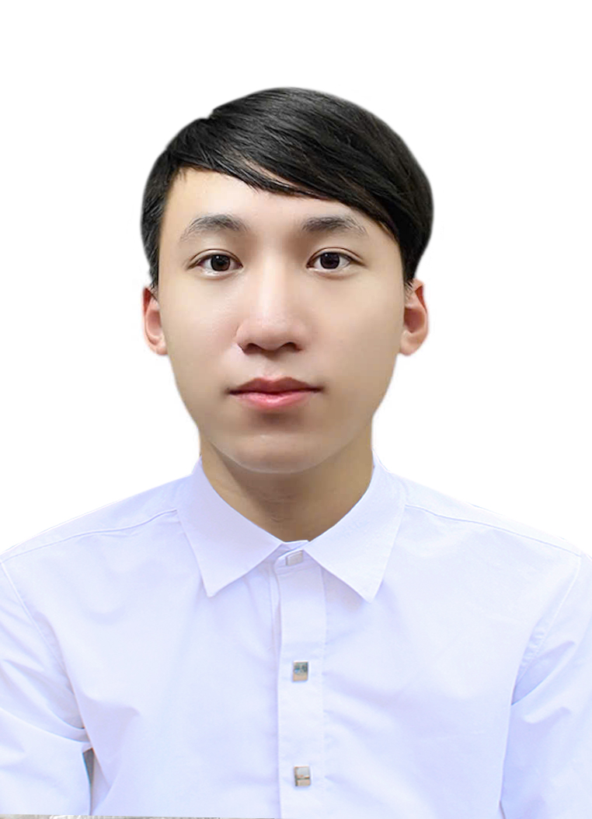

HIGH SCHOOL STUDENT

☎ +84 868372403

✉ dungpt2007@gmail.com

PHAM TIEN DUNG



ACADEMIC PRIZES & SCORES

* Consolation Prize in Vietnamese Physics Olympiads (2024-2025).
* First Prize in Hanoi Physics Olympiads (2024-2025).
* Second Prize in Hanoi Physics Olympiads (2023-2024).
* IELTS: 6.5
* SAT: 1420

EXPERIENCES

* 1 out of 20 students in Hanoi who have the honor to attend the Vietnamese Physics Olympiads.
* Participated in some experimental projects related to physics: Water Rocket (2022-2023), Collision Experiment (2023-2024).
* Went through basic programming courses such as the SIC programming course, CS50.
* Translate and compile some Physics handouts, references for students studying for Olympiads.

EDUCATION

* 2018-2022: Cau Giay Secondary School
* 2022-2025: Nguyen Hue gifted High School

AACC

* Ability: I am a gifted Physics student. I usually searched for materials in that field during school, so I believe I am quite skilled at Physics.
* Aspiration: I strongly desire to design a website that will provide useful knowledge to students who have a passion for Physics despite my lack of background in coding.
* Creativity: I tend to write code neatly but defensively to avoid possible bugs. I am also prone to new, fastidious details in experiments to lower the observational errors.
* Commitment: I hardly had any extra classes, so during my time cramming for the Physics test, I spent hours reading references, learning from peers and forums to bring my A-game to problem sets.

ABOUT ME

My name is Tien Dung. I love reading comics, physics, and programming. Realizing that an increasing number of students in Vietnam are passionate about physics, I applied to the Computer Science Department at VinUniversity to create a website to share materials and basic core concepts for competitive physics.